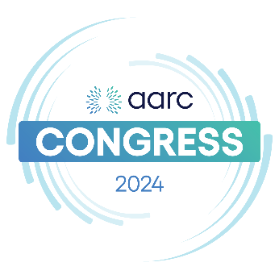
Directions for ACH/Wire Payments
Beneficiary Name: American Association For Respiratory Care
Bank: Bank of America
Bank Address: 1950 N. Stemmons Freeway, Ste 5010
Dallas, TX 75207
Account: 488106943175
Routing for ACH: 111000025
Routing for Wire: 026009593
Swift: BOFAUS3N

