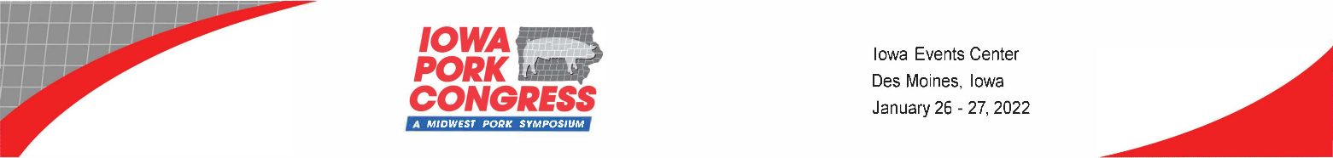
Sponsorship Opportunities

Trade Show Sponsor - $4,100 (non-exclusive)

- Full-page, four-color advertisement in the official show program ($2,214 value)
- Logo to appear in official show program and trade show signage
- Prime booth location
- Logo/booth number to appear on 15 LED screens outside of trade show floor and meeting rooms

Skywalk Floor Graphic (Carpet) - $5,000 (exclusive)

- Logo or product graphic located on the carpeted area between the double doors west to the end of the main skywalk hall overlooking the tradeshow floor. (Art files supplied by sponsor. SpeedPro is the service provider)
- Sponsor will be responsible for the cost of materials.
- Recognition on all LED screens

Registration Windows - $6,500 (Exclusive)
- Graphics on 6 separate windows (single faced)
- Price includes material and install (Art files supplied by sponsor)
- Recognition in the show program
- Recognition on all LED screens

Escalator (Registration to Seminars) - $7,500 (Exclusive)
- Graphics on 2 escalators (Up and Down - Single Faced)
- Materials are at additional cost (Art files supplied by sponsor. SpeedPro is the service provider)
- Recognition in the show program
- Recognition on all LED screens

Trade Show Floor Graphics - $5,000 (Exclusive)
- Graphics applied to aisle carpet in the main tradeshow hall (B &C)
- Materials are additional charges and would be produced and applied by (Freeman Co.)
- Recognition in the show program
- Recognition on all LED screens

Coffee Sponsor - $3,000 (Non - exclusive)

- Sponsor coffee at the Iowa Pork Producers Association’s “Pork Plaza”
- Logo to appear on signage at the coffee station
- Recognition in the show program

